Program 1: Strong number

import java.util.\*;

class p1{

public static void main(String args[]){

Scanner sc=new Scanner(System.in);

int n=sc.nextInt();

int sum=0;

int n1=n;

while(n1!=0){

int d=n1%10;

int fact=1;

for(int i=1;i<=d;i++){

fact=fact\*i;

}

sum+=fact;

n1=n1/10;

}

if(n==sum){

System.out.println(n+" "+"is a strong number.");

}

else{

System.out.println(n+" "+"is not a strong number.");

}

}

}

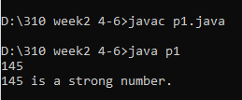

Program 2: Weekend or Weekday

import java.util.\*;

class p2{

public static void main(String args[]){

Scanner sc=new Scanner(System.in);

String w=sc.nextLine();

switch(w){

case "Monday":

case "Tuesday":

case "Wednesday":

case "Thursday":

case "Friday":

System.out.println(w+" "+"is a weekday.");

break;

case "Sunday":

case "Saturday":

System.out.println(w+" "+"is a weekend.");

break;

default:

System.out.println(w+" "+"is a invalid day.");

}

}

}

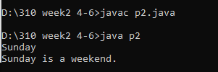

Program 3:

1. Zero one triangle pattern:

import java.util.\*;

class p31{

public static void main(String args[]){

Scanner sc=new Scanner(System.in);

int n=sc.nextInt();

int i,j;

for(i=1;i<=n;i++){

for(j=1;j<=i;j++){

if((i+j)%2==0){

System.out.print("1 ");

}

else{

System.out.print("0 ");

}

}

System.out.println();

}

}

}

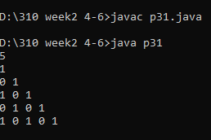

1. Number inc reverse pattern:

import java.util.\*;

class p32{

public static void main(String args[]){

Scanner sc=new Scanner(System.in);

int n=sc.nextInt();

int i,j;

for(i=n;i>=1;i--){

for(j=1;j<=i;j++){

System.out.print(j);

}

System.out.println();

}

}

}

